**Project Design Phase-II**

**Data Flow Diagram & User Stories**

|  |  |
| --- | --- |
| Date | 15 October 2022 |
| Team ID | PNT2022TMID16776 |
| Project Name | SMART SOLUTION FOR RAILWAYS |
| Maximum Marks | 4 Marks |

**Data Flow Diagrams:**

A Data Flow Diagram (DFD) is a traditional visual representation of the information flows within a system. A neat and clear DFD can depict the right amount of the system requirement graphically. It shows how data enters and leaves the system, what changes the information, and where data is stored.

**DATA FLOW DIAGRAM**

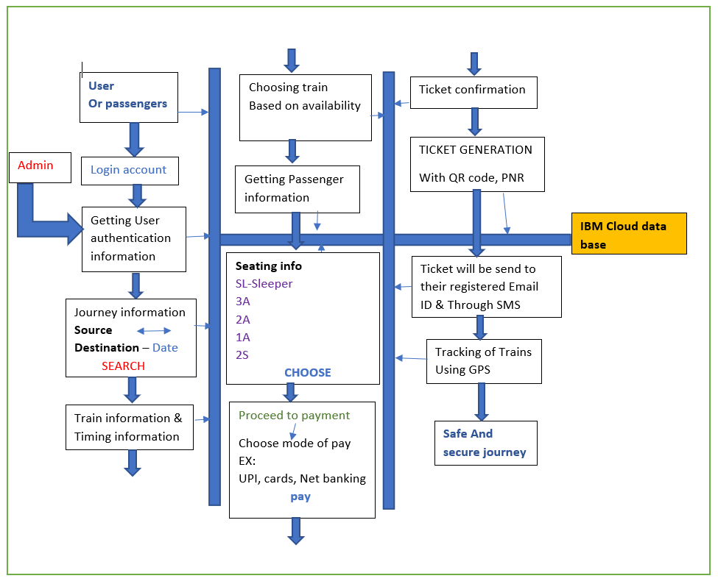

**User Stories**

Use the below template to list all the user stories for the product.

| **User Type** | **Functional Requirement (Epic)** | **User Story Number** | **User Story / Task** | **Acceptance criteria** | **Priority** | **Release** |
| --- | --- | --- | --- | --- | --- | --- |
| Passenger | Registration | USN-1 | As a passenger, I want to create a login credentials so I can securely access myself service online account. | Input data fields to enter:  1.Username/email  2.Password  3.Re-enter password  4.Security question  5.Security answer | High | Sprint-1 |
|  |  | USN-2 | As a user, I will receive confirmation email once I have registered for creating an account. | I can receive confirmation email & click confirm. | High | Sprint-1 |
|  |  | USN-3 | As a user, I can also create an account using Google. | I can register & access my account by using Google Login details. | High | Sprint-2 |
|  |  | USN-4 | As a user, I can also create an account using Facebook. | I can register & access my account by using Facebook login details. | Medium | Sprint-3 |
|  | Login | USN-5 | As a user, I can login to the account by entering my email and password.  As a user, I can login to the account through Facebook if I previously registered with it.  As a user, I can reset my password if I have forgotten my password. | I can login to the system so that my information can only be accessed by me. | High | Sprint-1 |
|  | My Account | USN-6 | As a user, I can view my personal account.  As a user, I can edit my Profile. . | I can use my personal account for booking process. | High | Sprint-1 |
| Customer Care Executive |  | CCE-1 | As a customer care executive ,I can take complaints ,answer calls from the customers regarding all the queries. | Pays attention to customer satisfaction to understand what services need improvements.  Customer care executive should be able to assist the users by easily communicating with them. | High |  |
| Administrator |  | ADMIN-1 | As an administrator I receive an email notification when a new user is registered. | The admin has the control over the new user by receiving a notification. . | High |  |
|  |  | ADMIN-2 | As an administrator I am able to add a new person to the database and backup can also be done. | The admin has the ability to access the database. | Medium |  |
|  |  | ADMIN-3 | As an administrator I am able to view content that to be viewed. | The details of the user should be given to the administrator impeccably when they request it. | Medium |  |